**TASKS PERFORMED**

1. Created a FlytBase account.

Attaching the screenshot.

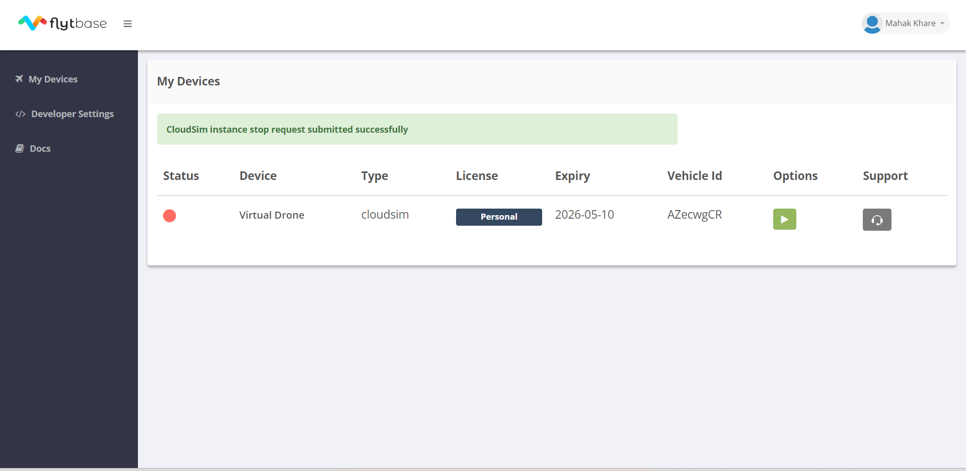

1. Downloaded the .zip file consisting of flytsim-docker-0.2.4 folder, further the file consisted of linux, windows, mac, Readme files.
2. On clicking the windows file, the setup.ps1 was operated properly.
3. The XLaunch application was installed properly.
4. The setup for the docker was done properly.

Attaching the screenshot of the terminal window.

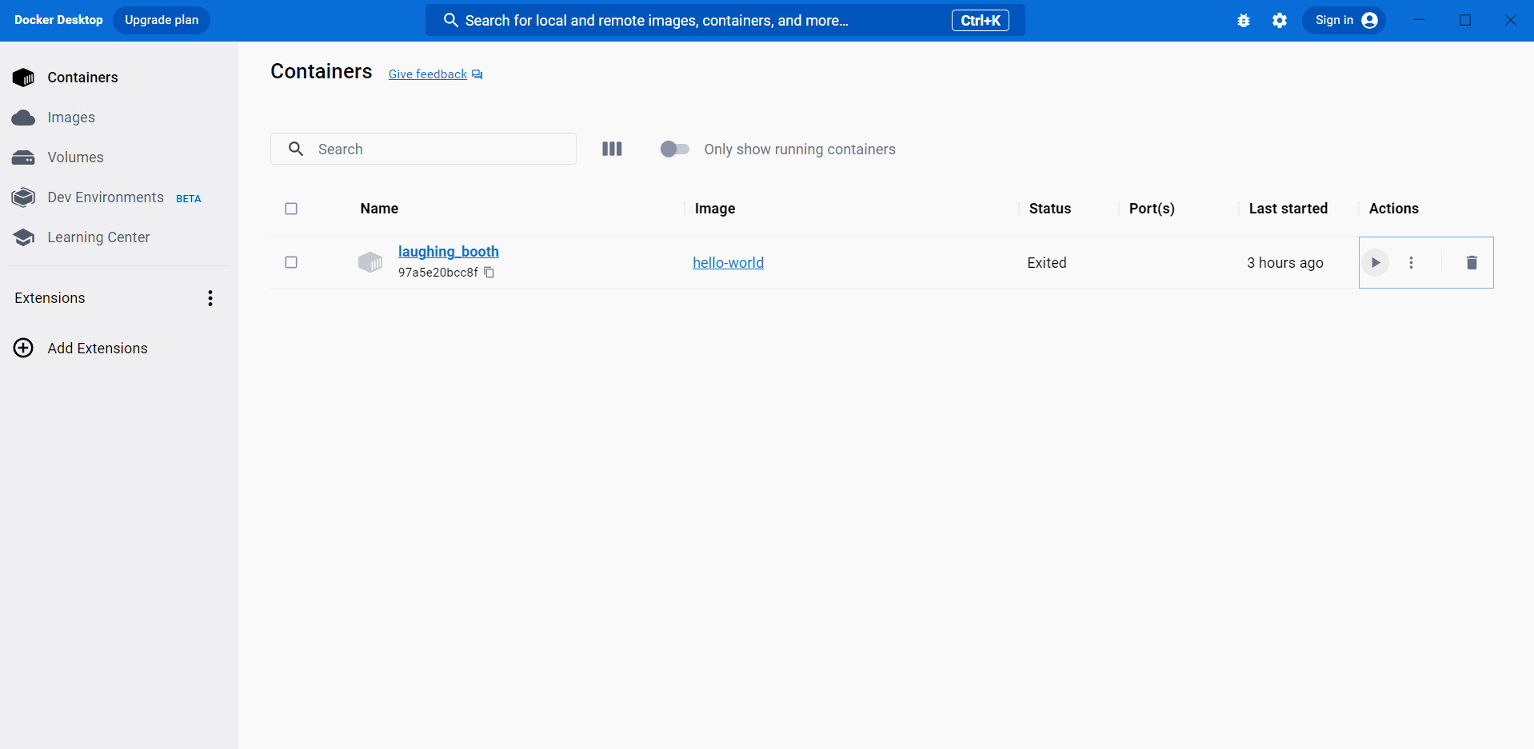

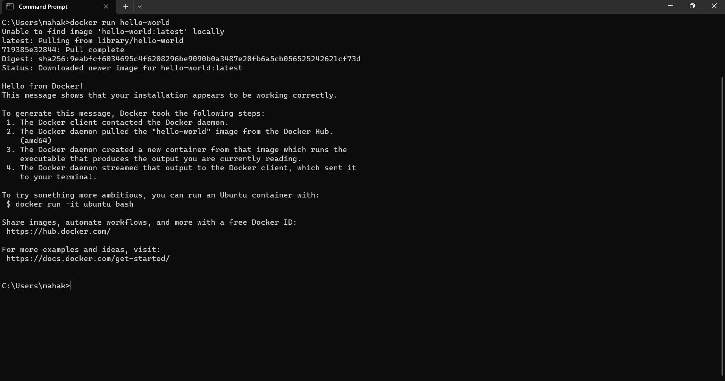

**PROBLEMS FACED**

1. Since I have AMD GPU only, there were some issues that I was facing. I was only able to go with APM-SITL.
2. Even after setting the properties in the correct way, the setup.ps1 was not executing properly.

Therefore, I was unable to move further with the process.